**Geometric Wall Art Prints & Framed Artwork**

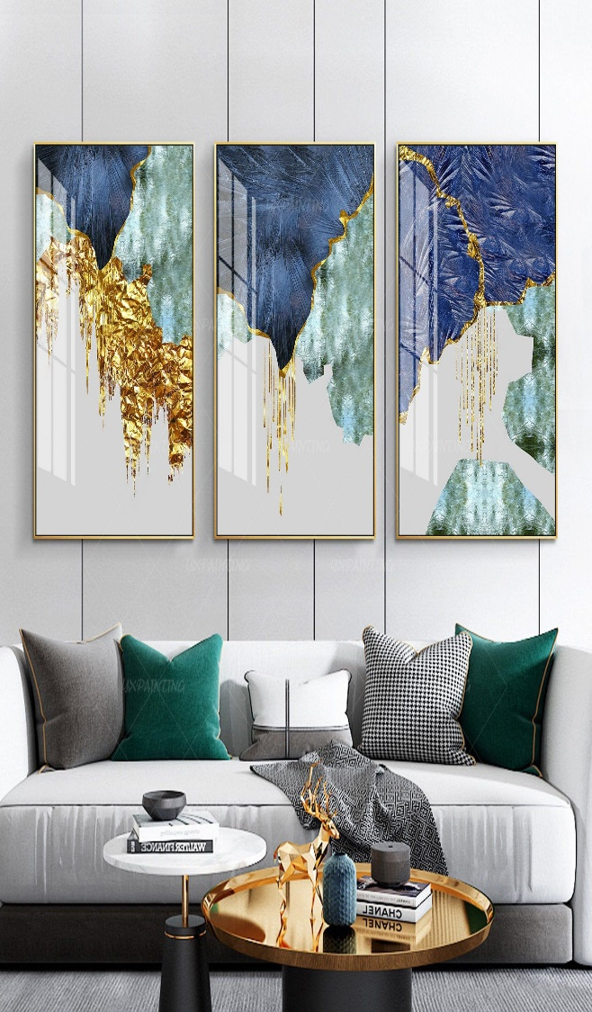Geometric wall art prints and framed artwork are a stylish and contemporary addition to any home or office decor. These pieces feature bold geometric shapes, such as triangles, circles, squares, and polygons, arranged in visually captivating patterns that can range from simple and minimalistic to complex and layered. Printed on high-quality paper or canvas and often framed in sleek, modern frames, these artworks add structure and visual interest to a wall while maintaining a clean, organized aesthetic. Available in a wide array of colors, from monochromatic designs to vibrant, multi-tonal palettes, geometric prints can complement a variety of interior styles—from minimalism to eclectic design. Perfect for living rooms, bedrooms, or offices, these artworks bring a sophisticated touch that can easily elevate the atmosphere of any space.